Advanced Java Bootcamp

Exam 1 - Java core:

Create a new package javabootcamp.basic.exam and answer the following questions in a single Runner.java file.

Before each answer add a comment with the question title. For example:  
// Question 1

Upload the code to your github repository and also send it to me via Slack in a private message.

Question 1:

Answer this question inside a comment block in the beginning of the Runner.java file.

Describe in short (1 – 3 sentences) - What is the difference between JDK, JRE, and JVM?

Question 2:

Answer this question inside a comment block right after the answer for question 1.

Describe each of the steps of executing a java program. The process starts with a written code and finishes with a running program. Describe each step in 1-3 sentences.

Question 3:

A nonnegative integer is called a palindrome if it reads forward and backward in the same way. For example, the numbers 5, 121, 3443, and 123454321 are palindromes. Write a method that takes as a parameter a nonnegative integer and returns true if the number is a palindrome; otherwise, it returns false.

Question 4:

Write a method that takes 2 arrays of integers and constructs a new array from them. The new array should be initialized with the array that has the smaller sum of elements first and followed by the other array. The last 2 elements of the new array should be the total sum of the two arrays and absolute difference between the sum of each array.  
you can use this example for clarifying.

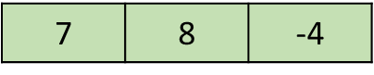 First array

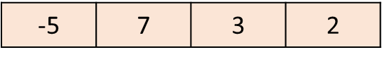Second array

Returned array